Holiday park exercise

After review of the companies net revenue over the previous year, we can see that the company had its most successful year in 2019. This resulted in a decline performance in year 2020 and 2021.

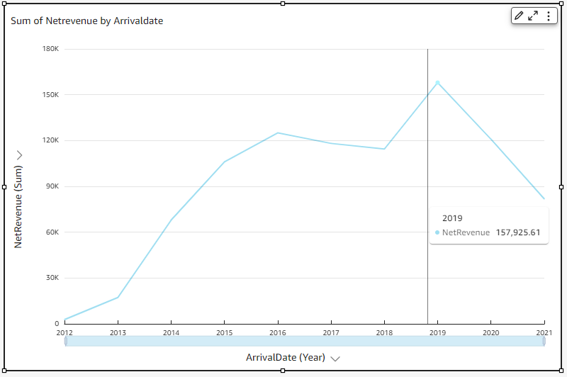

After a month drill down of this performance, we can see that the periods from August to November in both 2020 and 2021 showed the poor performance.

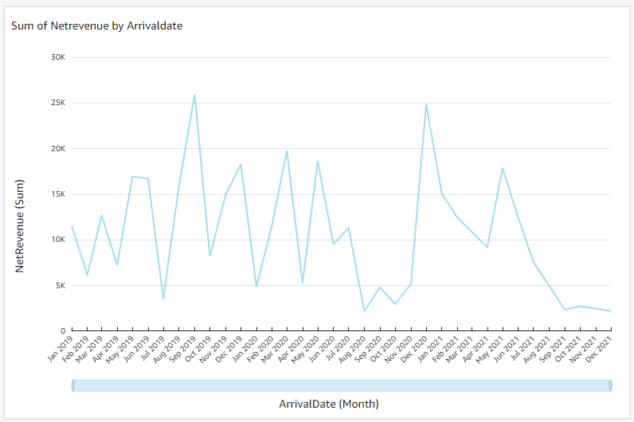



As shown above there has been on average an approx. 70% reduction on net in Aug-Nov every year since 2019. As should our plan is to focus on increasing and driving the sales within these months.

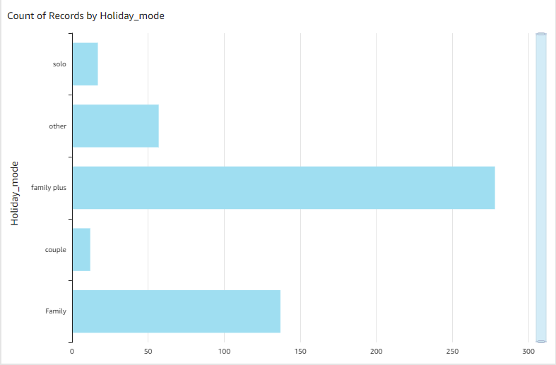

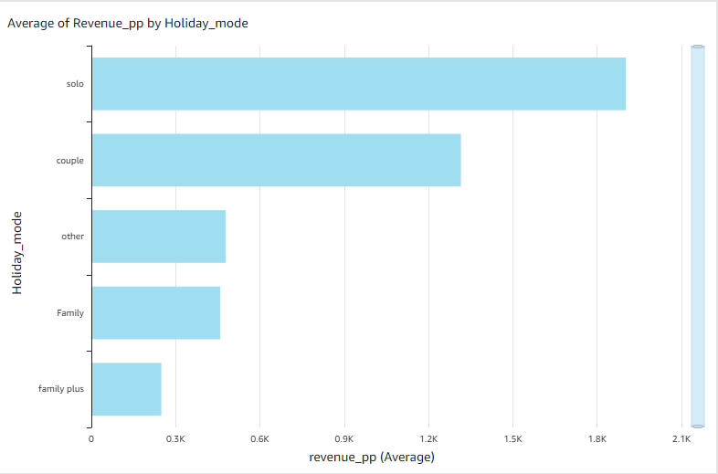

We can also see form the above graphics that solo and couple travellers/holiday types are the lowest booked holidays within the organisation even though they driver the highest and second highest revenue per person.

As such the strategy will be based around advertising and selling holidays for these types. This fits well with the demographic of sales per month also as there are less family holidays in Aug-Nov due to kids going back to schools.

I suggest the holiday park advertises an adult only Holiday get away between these times and tailors’ specific events to fit this demographic also. These could be various things for the specific sites to decide based on their facilities for example. Speed dating or salsa dancing etc.

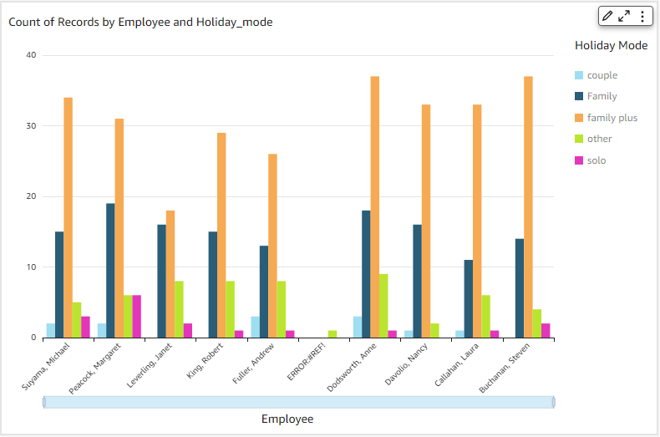

Alongside this a specific sales competition for the sales employee should be introduced to improve sales in this area as solo holiday sales are the lowest selling point across the whole sales team. As shown above